Writing Negative Messages
Using the indirect approach for negative Messages

The indirect approach helps prepare readers for the bad news by presenting the reasons
for it first. However, the indirect approach is not meant to obscure bad news, delay it, or
limit your responsibility. Rather, the purpose of this approach is to ease the blow and help
readers accept the situation. When done poorly, the indirect approach can be disrespectful
and even unethical. But when done well, it is a good example of audience-oriented communication crafted with attention to ethics and etiquette. Showing consideration for the
feelings of others are never dishonest.

Opening with A BUFFER
Messages using the indirect approach open with a buffer: a neutral statement that establishes
common ground with the reader without revealing the main idea. A good buffer can express your appreciation for being considered (if you’re responding to a request), assure the reader of your attention to the request, or indicate your understanding of the reader’s needs. A good buffer also needs to be relevant and sincere.

In contrast, a poorly written buffer might trivialize the reader’s concerns, divert attention
from the problem with insincere flattery or irrelevant material, or mislead the reader
into thinking your message actually contains good news.

Consider these possible responses to a manager of the order-fulfillment department
who requested some temporary staffing help from your department (a request you won’t
be able to fulfill):

Our department shares your goal of processing orders quickly and efficiently.

As a result of the last downsizing, every department in the company is running shorthanded.

You folks are doing a great job over there, and I’d love to be able to help out.

Those new state labor regulations are driving me mad over here; how about in your department?

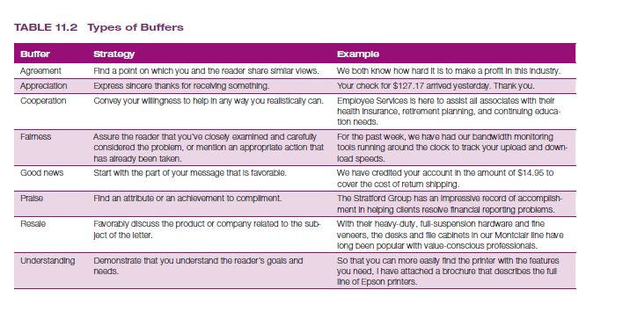

Providing reasons and additional information
An effective buffer serves as a transition to the next part of your message, in which you
build up the explanations and information that will culminate in your negative news. An
ideal explanation section leads readers to your conclusion before you come right out and
say it. In other words, the reader has followed your line of reasoning and is ready for the
answer.

As much as possible, avoid hiding behind company policy to cushion your bad news.
If you say, “Company policy forbids our hiring anyone who does not have two years’ supervisory experience,” you imply that you won’t consider anyone on his or her individual merits. By sharing the reasons behind the policy (if appropriate in the circumstances), you can give readers a more satisfying answer. Consider this response to an applicant:

Because these management positions are quite challenging, the human resources department has researched the qualifications needed to succeed in them. The findings show that the two most important qualifications are a bachelor’s degree in business administration and two years’ supervisory experience.

Continuing with A CLEAR Statement of The BAD News
After you’ve thoughtfully and logically established your reasons and readers are prepared
to receive the bad news, you can use three techniques to convey the negative information
as clearly and as kindly as possible. First, deemphasize the bad news:
●● Minimize the space or time devoted to the bad news—without trivializing it or withholding any important information.
●● Subordinate bad news in a complex or compound sentence (“My department is
already shorthanded, so I’ll need all my staff for at least the next two months”). This
construction presents the bad news in the middle of the sentence, the point of least
emphasis.
●● Place bad news in the middle of a paragraph or use parenthetical expressions (“Our
profits, which are down, are only part of the picture”).

Second, if appropriate, use a conditional (if or when) statement to imply that the
audience could have received, or might someday receive, a favorable answer (“When you
have more managerial experience, you are welcome to reapply”). Such a statement could
motivate applicants to improve their qualifications. However, avoid any suggestion that
you might reverse the decision you’ve just made, and refrain from any phrasing that could
give readers false hope.

Third, emphasize what you can do or have done rather than what you cannot do. Say
“We sell exclusively through retailers, and the one nearest you that carries our merchandise
is . . .” rather than “We are unable to serve you, so please call your nearest dealer.”

When implying bad news, however, be sure your audience will be able to grasp the
entire message—including the bad news. Withholding negative information or overemphasizing positive information is unethical and unfair to your reader. If an implied message might lead to uncertainty, state your decision in direct terms.

Closing on A RESPECTFUL note

As with the direct approach, the close in the indirect approach offers an opportunity to
emphasize your respect for your audience, even though you’ve just delivered unpleasant
news. Express best wishes without ending on a falsely upbeat note. If you can find a
positive angle that’s meaningful to your audience, by all means consider adding it to your
conclusion. However, don’t try to pretend that the negative news didn’t happen or that it
won’t affect the reader. Suggest alternative solutions if such information is available and
doing so is a good use of your time. If you’ve asked readers to decide between alternatives
or to take some action, make sure that they know what to do, when to do it, and how to
do it. Whatever type of conclusion you use, follow these guidelines:
●● Avoid an uncertain conclusion. If the situation or decision is final, avoid statements
such as “I trust our decision is satisfactory,” which imply that the matter is open to
discussion or negotiation.
●● Manage future correspondence. Encourage additional communication only if you’re
willing to discuss the situation further. (If you’re not, avoid statements such as “If
you have further questions, please write.”)
●● Express optimism, if appropriate. If the situation might improve in the future, share
that with your readers if it’s relevant. However, don’t suggest the possibility of a positive
change if you don’t have insight that it might happen.
●● Be sincere. Steer clear of clichés that are insincere in view of the bad news. (If you
can’t help, don’t say, “If we can be of any help, please contact us.”)
Keep in mind that the close is the last thing audience members have to remember
you by. Even though they’re disappointed, leave them with the impression that they were
treated with respect.

